Skip to Main Content


Home

This Is Us

Our Menu

Order Online (https://order.toasttab.com/online/dirty-breakfast)

Contact Us

Log In
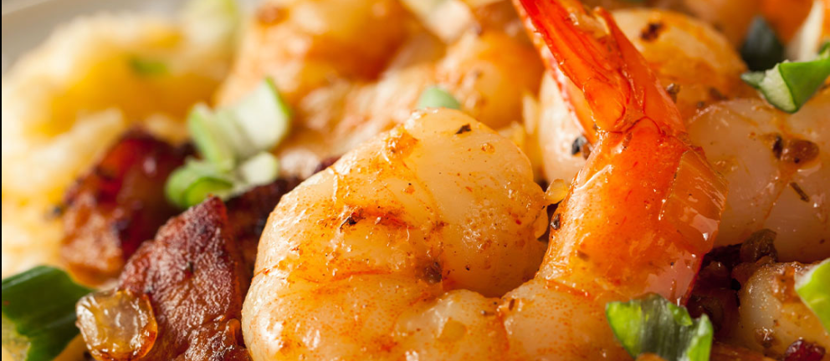
Restaurant Est. 2023
Your Go-to Spot for Breakfast- Brunch & Late Night eats
Order Now
Our Menu
OPEN 7AM-12AM TUE- WED| 7AM-2AM THURS | 7AM-3:30AM FRIDAY| 8AM- 3:30AM SATURDAY | 9AM-8PM SUNDAY
Breakfast.
EVERYDAY FAVORITES MADE FRESH
PANCAKES - WAFFLES - FRENCH TOAST - BISCUITS - -SAUSAGE - BACON - EGGS - GRITS - BURRITOS & SO MUCH MORE
ORDER NOW
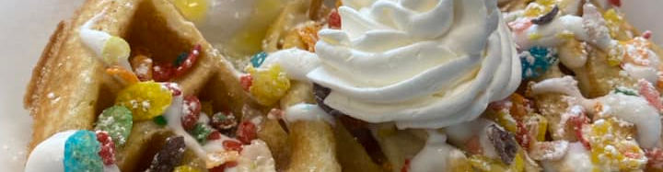
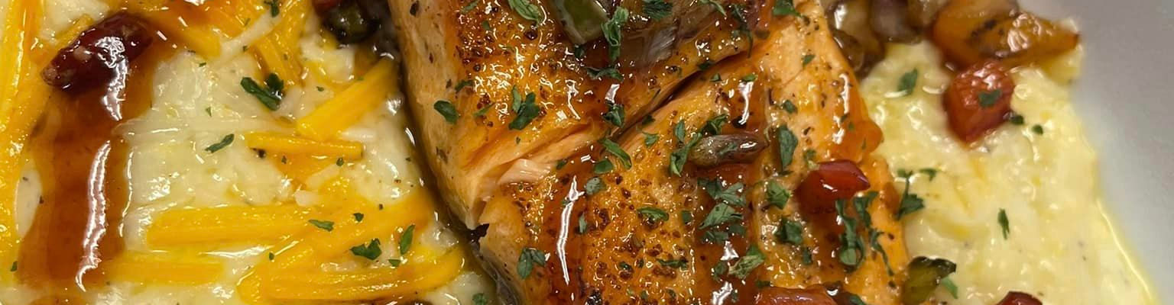
Brunch & Dinner
NOT AN EARLY BIRD NO WORRIES....
SALMON CROQUETTES - T BONES - RIB EYE - LAMB CHOPS - CATFISH - WINGS - CHICKEN STRIPS - PORK CHOPS - SALMON - SHRIMP & GRITS - BISCUITS & GRAVY & MORE
CHECK OUT OUR MENU
Drop By for a Bite.
Address
10981 HAMILTON AVE
CINCINNATI OHIO 45231
HOURS OF OPERATION
M
TUESDAY 7AM-12AM
WEDNESDAY 7AM-12AM
THURSDAY 7AM-2AM
FRIDAY 7AM-3:30AM
SATURDAY 8AM-3:30AM
SUNDAY 9AM-8PM
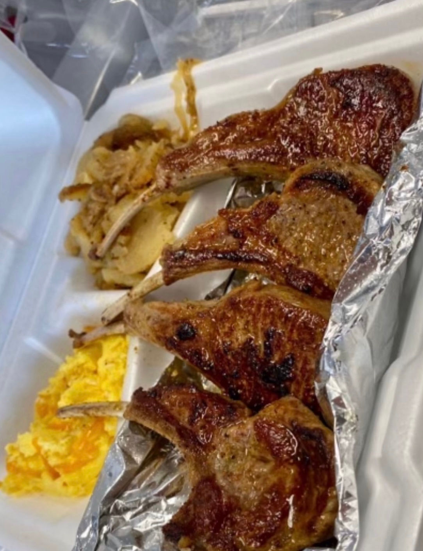
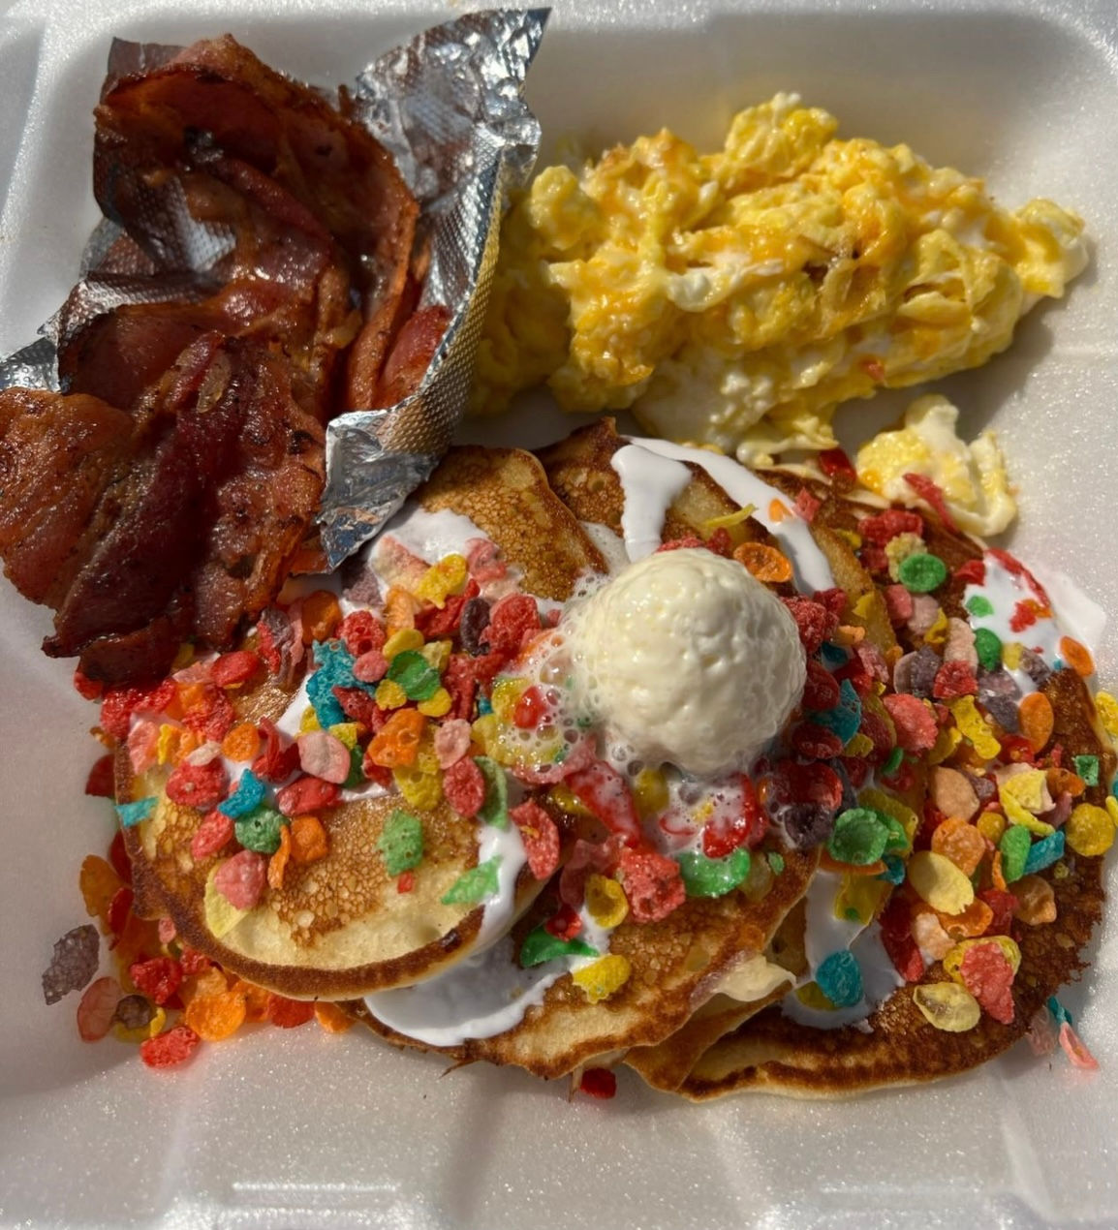
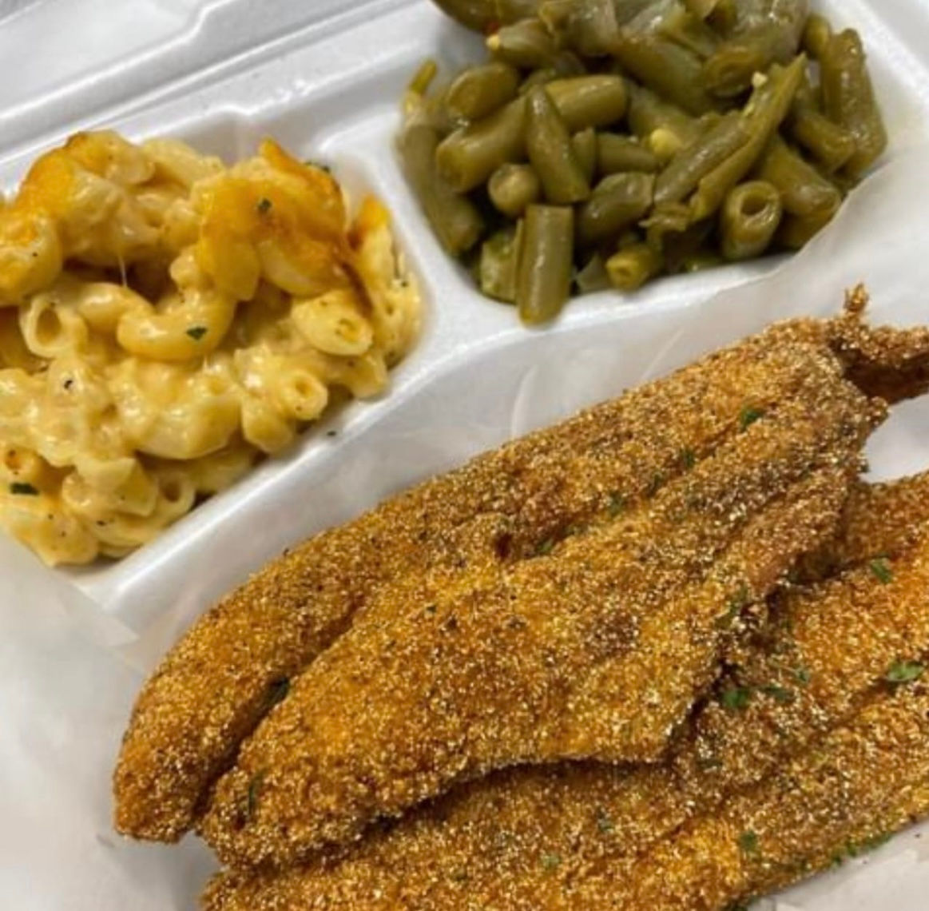
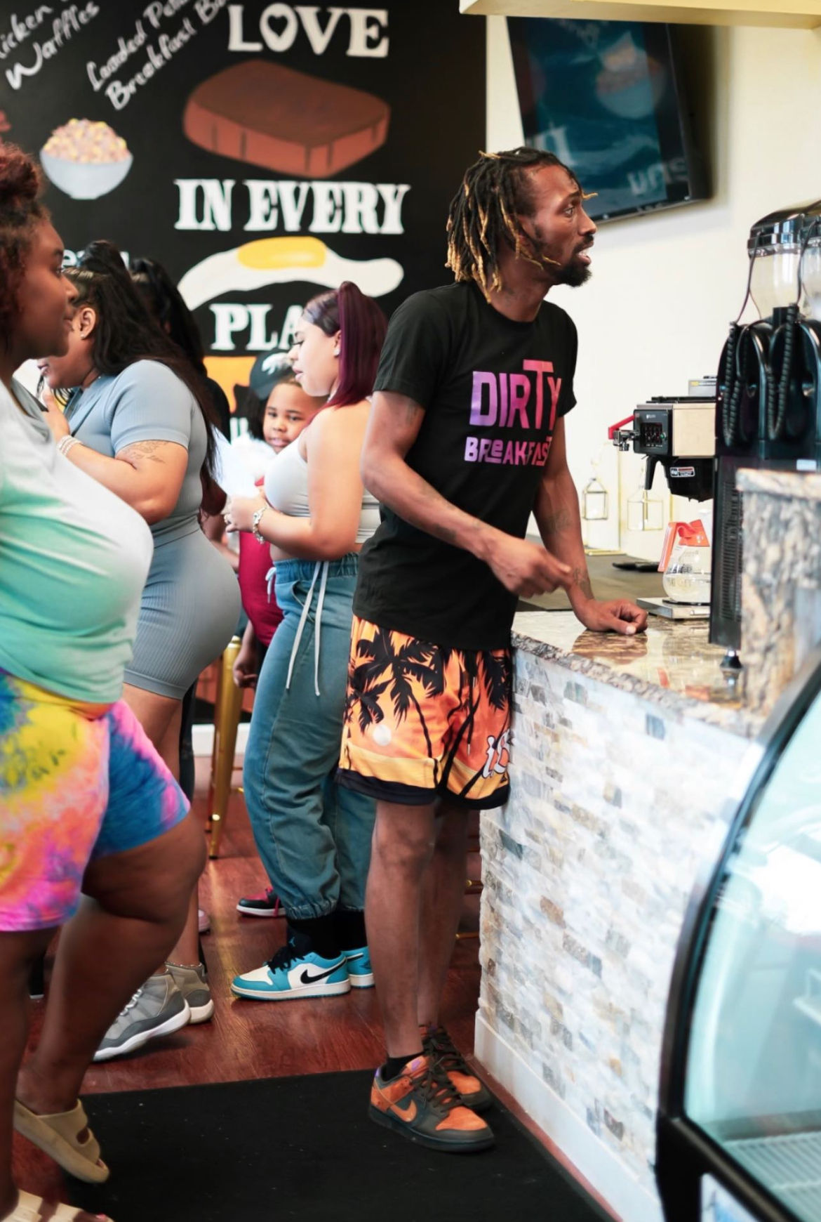
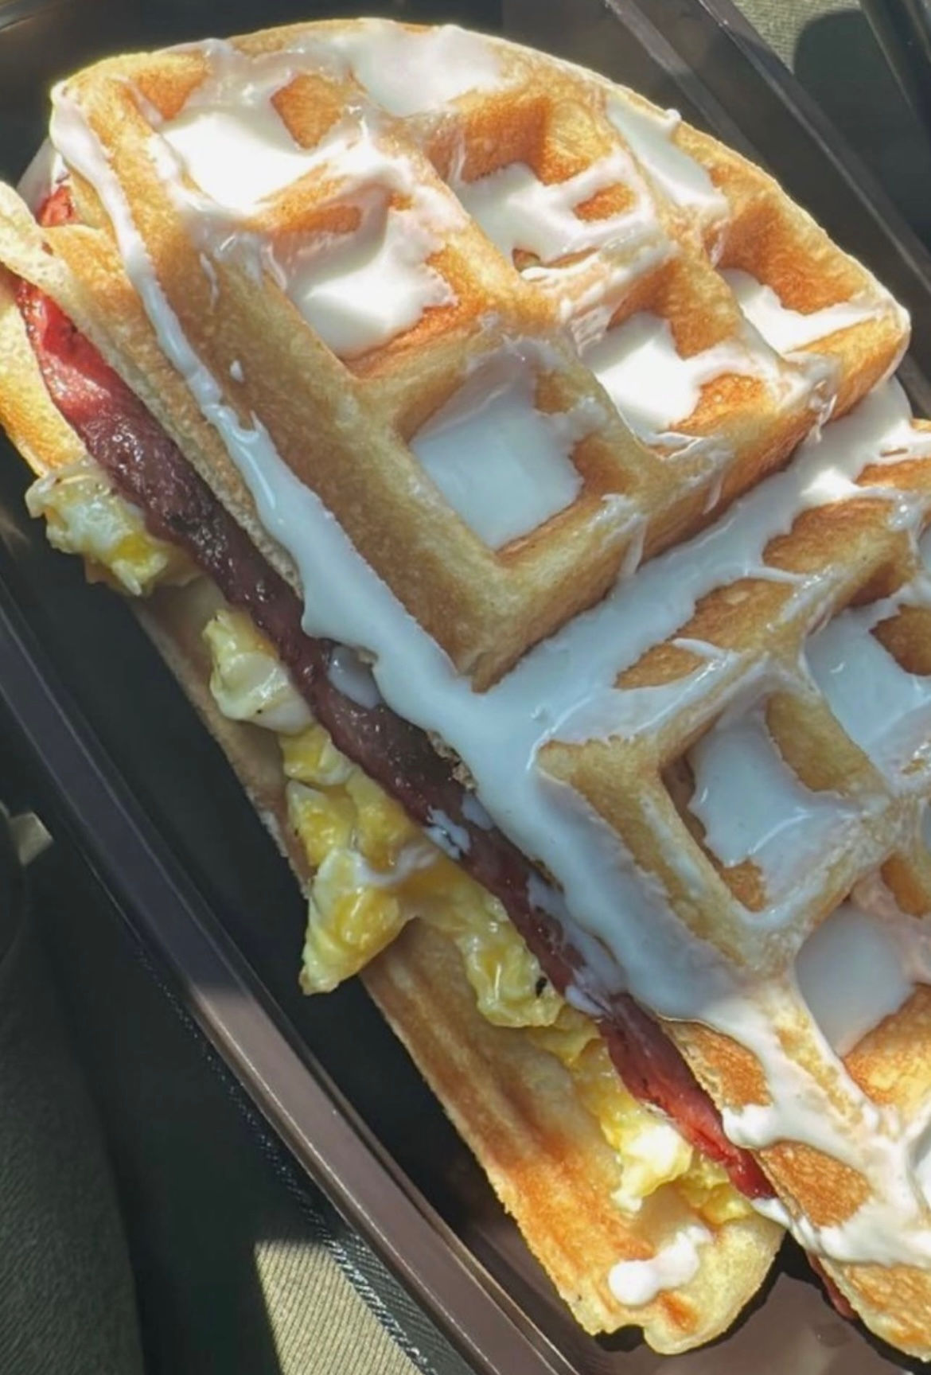
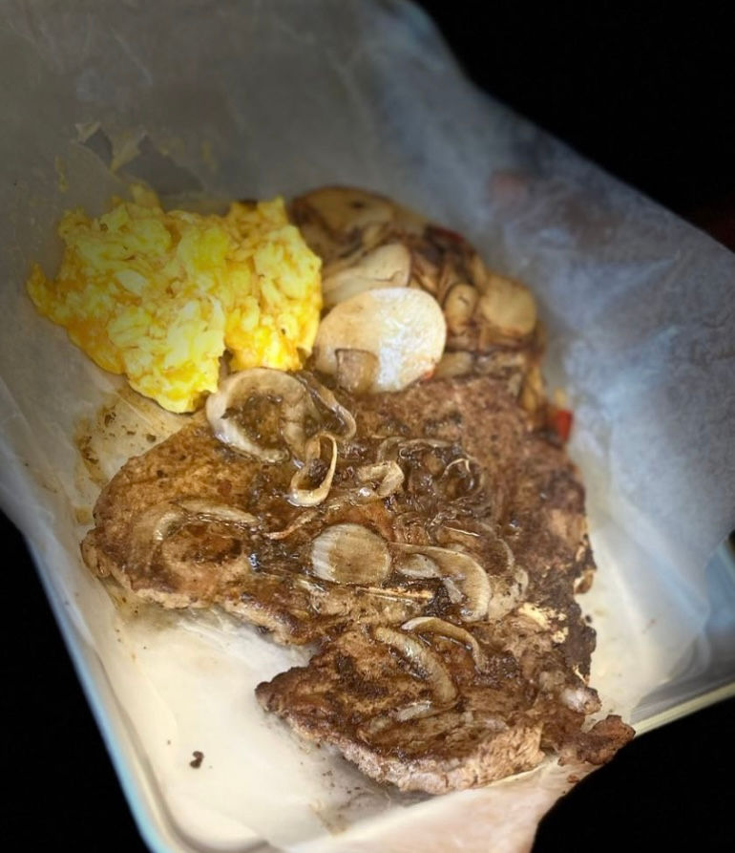
Newsletter

Stay up to date with all the latest from
DirTy Breakfast
Email
Join

Talk to Us
Instagram
513-386-9720
10981 HAMILTON AVENUE
CINCINNATI OHIO 45231
Facebook
© 2023 DIRTY BREAKFAST CREATED BY WDBD

